**Everything to play for: the polls are close, tight race is predicted for Hastings & Rye**

Our Press release - released fro immediate reporting at - 29.05.2017 5-PM.

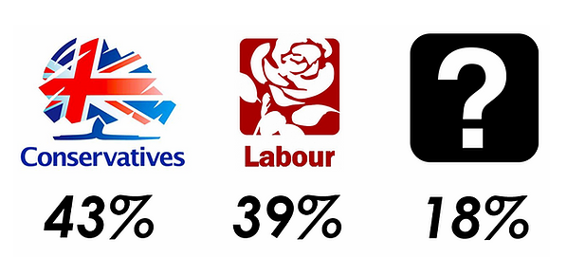

Everything to play for: the polls are closing and a tight race is predicted to win Hastings and Rye

Researchers from Coastal Action, a new coastal regeneration think-tank based in St Leonards have been out and about over the last week talking to local voters about their voting intentions for the General Election on June 8th.

And they have just released their findings, which suggest that we could be looking at a very tight race in the Hastings and Rye constituency, held from 2010 by the Conservative Party candidate, Home Secretary Amber Rudd.

Coastal Action figures mirror the sharp decline in support for Conservative party following their manifesto launch on May 18th, which has seen a significant drop in their poll lead and am unprecedented mid-election U turn following widespread concern over their proposals for elder care, widely dubbed the 'dementia tax'.

Their poll, based on a face-to-face survey on 130 voters in 5 locations across the Hastings and Rye constituency, generated the following figures:

Con 43%

Lab 39%

Undecided 18%

This represents a swing of 2.9% from the Conservatives to Labour.

Commenting on the polling, Coastal Action founder and Director, James Prentice, said, " the groundwork was conducted in a range of locations selected to represent different demographies and political preferences. Sampling also took account of the need to involve all age groups and for gender balance. We also went for a large sample, to ensure the widest possible range"

Chris Connelley, Co-Director and part of the fieldwork team, said, " the conversations as we went about asking our questions were fascinating and it was clear from very early on that the Conservative care policy has had a major negative impact in terms of voter perception. This is demonstrated through an apparent softening of support for Mrs May and her party, with a number of former Conservatives declaring as undecided, though this could, of course, simply represent the ‘shy Tory’ effect, where supporters of this party are less likely to ' out' themselves."

" The behaviour of former UKIP voters is also crucial" added Prentice," If many of them turn out and vote Conservative this time, as widely predicted, it may reinforce the Conservative vote, though Amber Rudd's active role in the REMAIN campaign may deter any straight transfer of allegiance"

The Labour vote, by contrast, seemed firm, with just 2 narrative references to the party leader Jeremy Corbyn. In one case, a former Labour voters said he would be voting Conservative; the other said he would not vote.

The Liberal Democrats, UKIP and Independent candidates enjoyed almost complete invisibility in polling. This is unsurprising, as the Liberal Democrats are focused on winnable seats elsewhere in the county, notably Lewes and Eastbourne, whilst UKIP, though running a candidate in the seat, are operating without the head of steam and celebrity Gogglebox candidate that gave them such a high profile in 2015 The Independent candidate, Nicholas Wilson, running without a party machine and with a tiny budget, has inevitably struggled to cross over into public consciousness.

A key factor in the eventual outcome will be the behaviour of the undecided voters who say they are certain to vote on June 8th, nearly half of whom identified as having voted Conservative in 2015. If they vote the same way this time, the Conservatives should win comfortably. If, however, there is switching to other candidates, or the undecided Conservatives stay at home, the potential is there for a major upset.

With just days to go, and such tight polling, the Coastal Action team believe that much will depend on the ability of the two main parties to mobilise their support. They argue that the Conservatives tend to enjoy an advantage with regard to getting out their vote, but note Labour's large and enthused local network, as well as the substantial numbers of recent registrations as factors that could tip the balance in their favour. ""If the weather is good on June 8th, the turnout is high and there are a lot of young people in the queues, it might just be Labour's night. That said, the prediction must still be for a Conservative win "

To find out more about Coastal Action, go to www.coastalaction.co.uk.

For more information on the polling, contact

James Prentice on 07584 750589

Chris Connelley on 07855 208374

Tags:

* [polling](https://www.coastalaction.co.uk/blog/tags/polling)