**Coastal Action poll press release/ for immediate issue**

Our new poll shows the **Conservatives ahead** and projects they **likely** will **hold the seat** a week before polling, but with **large numbers** of voters still **undecided.**

With less than a week to go before the next election, Coastal Action’s newly released local polling for the constituency of Hastings and Rye puts the Conservatives comfortably ahead on 40.5%, with Labour in second place on 30.5% and the Liberal Democrats third on 12.4%. The Independent candidate Paul Crosland secured 1.6%.

**Adjusting figures to** **remove undecided voters** puts the Conservatives on 46.8%, Labour on 36.3%, the Liberal Democrats on 14.8% and the Independent on 1.9%.

Tellingly, however, sampling revealed high levels of undecidedness, with 14.8% of voters still needing to make up their mind. Most assured us that they were determined to vote but not yet how.

The poll was undertaken in a range of locations representing the breadth of the parliamentary seat, which includes Hastings, Rye as well as more rural areas.

Coastal Action Director and founder, James Prentice, a PhD researcher at the University of Sussex commented, “the findings here in Hastings and Rye derived over the first few days in December are absolutely consistent with national polling, which identifies a Conservative lead of around 10%.

Based on our findings, our expectation is that the Conservatives will hold the seat on December 12th.

That said, the large number of voters yet to make up their minds adds a degree of uncertainty to that prediction. Given that when asked, most voters indicate they are determined to vote, there is still a possibility for significant change in the poll share.

If much of this undecided vote moves towards Labour in the final days of the campaign, as happened towards the end of the last election in 2017, the current gap would close rapidly.

However, it should be noted that the undecided voters Labour needs to win over come from a range of age groups, voter backgrounds and amongst Remainers and Leavers. Uniting all these diverse groups behind the party in such a short time clearly presents a formidable challenge.”

Polling was undertaken between 1-5 December 2019 before the controversy over comments made by the Conservative candidate at a Hastings hustings on 5 December.

Summary of our findings

**The result of our poll projects the following:**

* A likely Conservative victory in Hastings&Rye.
* The Conservatives are projected to lead by an average of **9-10 points** with undecided people counted**.**
* There is an average margin error of 5%, making the potential Conservative lead range from 7 – 15%, most likely somewhere in the range of an 8-12% lead. The absolute **average Lead** we calculated for the Conservatives is a **10.21% lead.**
* **However,** there is a **huge caveat** there are a large amount of **undecided voters.** If this flowed towards Labour this could still cause Labour to rapidly close the gap like in the last election. Therefore, the election race **still can’t be called**, although the Conservatives are still favourites to win the seat. Percentage wise it **85% likely the Conservatives will win and 15% likely Labour will.**
* **Undecided voters do have the potential to decide who wins this seat still and nothing is settled yet.**

**Press release ends.**

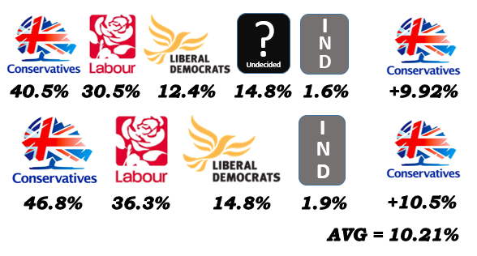**See the poll on our website** [**www.coastalaction.co.uk/polls**](http://www.coastalaction.co.uk/polls)

