

Does the level of Social capital affect the performance of local government: A British case study, 2000 - 2010? A national, local comparison and single local council case study.

## Chapter 1 – Introduction & Literature Review – Area of Study:

This dissertation will look at the intense academic debate of the idea that a civic culture positively affects the quality of democratic performance. This dissertation question asks “does the level of SC affect the performance of local government: A British case study, 2000 -2010?” This dissertation question has originated from past research which has provided much new insights, bold claims, but inconclusive answers. Firstly, the observations made by Alexis de Tocqueville, in 1831, suggested that Americans who formed civic groups allowed states to be more governable (Kramnic 2003). Later Hanifan, in 1920, concluded that the use of community centres created better governance in deprived areas within America. (Hanifan 1920). Later followed by Almond and Verba’s civic culture study, which suggested more civically minded nations produced better democratic outcomes (Almond & Verba: 1989). Coleman has also suggested educational centres can create SC that helps educate its citizens, which results in a more governable nation (Coleman 1988). Reinforced through Robert Putnam’s study of SC, and its potential link to democratic performance of local government, within Italy (Putnam: 1993). Putnam’s study has led to a large increase in research of the civic cultures' relationship with government performance, resulting in many possible relationships between the two concepts (Boix 2009.) This can be with recent research, for example in Pattie’s study investigated the link between local government educational performance in Wales and levels of associational membership (Pattie, Seyd & Whiteley: 2004).

The research has provided much variation, which has created a desire to provide new evidence to attempt to add greater understanding of Putnam`s relationship claims. This essay will set out to do this through testing Putnam’s claims through focusing on SC and local government within Britain. This makes this study worthwhile precisely because of historical claims which suggests that declining SC may be causing declining trust in government, and may be a threat towards democracy (Warren 2001). Therefore testing SC levels in a democracy, which was once considered strong (Almond & Verba 1989), would have implications for democracy, politics and political research as it can help address the wider debate which claims Western democracies are weakening (Putnam 2002). This, combined with this area’s long historical relationship claims, is where this dissertation question originates from.

The core purpose of this paper is to ask can SC positively contribute towards better performing government? In this case focusing on local government within Britain in the years 20000 – 2010. Secondly, a key aim of this question is to produce results from the national, local comparison and local study that will show trends and relationships which can answer the question. Finally, this will allow this dissertation to address a gap in the literature and add to the current literature through: building on the work of Putnam by measuring SC as a single number, instead of several different measures for different variables, so the concept can be measured by one figure. It has been done like this in order to build on Putnam’s measure which has shown some elements of SC are related, whilst others are not, therefore providing confusion in whether the concept is related to government performance (Putnam 2000 & Whiteley 2012). The single measure will avoid this by taking all attributes into account, which Putnam has argued is needed to fully measure SC, and therefore fully test SC’s link to government performance (Putnam 2000). It will also add to the debate through testing the generalizability of the claim a form of a civic culture can help democratic institutions function more effectively, through using a unique local British case study. Furthermore, it will add to the debate through seeking to provide evidence that will test claims made in previous studies surrounding this area in British politics; such as testing claims made surrounding the trends of SC in Britain. This dissertation seeks establish a clearer set of trends in order to add to the current debate through providing greater clarity. It seeks to add to the debate through providing new information about the possible relationship between SC and local government performance, previously not done in the UK before, through using statistical stratification techniques. This will allow to estimate local SC levels as the only data available is through national studies, limiting the ability to understand variations across Britain due to the aggregation of data. This will add to the debate in firstly testing the generalizability of the relationship to different levels within the UK, secondly testing the possible different variations across different levels, and areas, across the UK and finally providing new evidence to establish a clearer set of causal relationships which may exist within Britain.

In order to explore this area of study further, the study will focus upon the relationship between two key concepts. Firstly, the concept of SC, secondly the concept of local government, both in the context of England. See pages 6-7 for more detailed definitions of the concepts this paper focuses on.

**So what?** Firstly, this question is important to explore as there is a gap in the literature. The relationship between the two concepts in question has not been investigated on a constituency level within Britain. So far this type of investigation has been conducted outside of the UK, and suggests there is a relationship (Putnam 1993). The generalizability of this claim can be tested within this British case study, helping to add to the debate and understanding of this claimed relationship and its level of generalizability. Furthermore, it will also allow the testing of post-stratification which may open up new ways to investigate SC and its relation to local government (Park, Gelman, and Bafumi 2004 & Hanretty 2014).

Secondly, another important reason to investigate this question is because of much disagreement and variation in causal links, definitions and statistical trends within this area of research. (Boix and Stokes 2009). Disagreement of SC statistical trends, within Britain, can be seen with Whiteley’s and Hall’s study showing different trends. Whiteley’s study in Britain showed decreases in trends (Whiteley 2012), whilst Hall’s show increases in trends (Hall in Putnam 2002). Causality conflicts can be seen in the studies of Whiteley, showing that SC had many variations in significance of its relationship to local government, but overall there was a significance (Whiteley 2012). Pattie’s study found that SC was related to government service delivery, but not related to local government performance over all (Pattie, Seyd, and Whiteley 2003). Importantly, initial research raises questions over what exactly is the statistical trend within Britain and its causal effect on local government. SC levels are important as SC may be a key indicator of wider citizen engagement, which is under a lot of academic debate. Stoker has shown both how SC and engagement may have both declined and risen (Stoker 2004). Also SC levels may increase the efficiency of local government performance, which may provide new knowledge in what exactly makes local government more cost effective. It is can also be argued to help better governance through creating greater ability for councils to deliver services and solve problems. Furthermore, this may add to the current political debate in how to make current savings being implemented on local government. This dissertation’s investigation will seek to add to current literature through measuring SC levels, and causal connections from 2001- 2010, through a new investigation at the local level in a British case study, which will provide a new test for an old academic problem.

Thirdly, this study is worthwhile as it will investigate potential causes that may strengthen local government within Britain. The cause of effective Local government is important in British political studies because firstly it forms the basis of a large and complex political structure that exists within the UK. Local government is the first level of politics for many people, and represents concerns and delivers many services important to people’s everyday lives. Importantly, this means that local government has a great impact on people’s ability to participate in politics. Because of this testing its strength and what causes its success is key to understanding what may be driving the quality of democracy in the UK, which has been under debate for decades (Almond & Verba: 1963, Stoker, 2006.) Furthermore, it is highly relevant to today’s debate around local government and localism within Britain. It firstly addresses the debate about how to best effectively deal with proposed cuts surrounding public and services spending, which is current in mainstream political debate. Such debate can be seen contemporary with local government cuts. The Adam smith institute argues it is no bad thing (Bowman 2014), whilst the Green party is urging action against further cuts (Lucas 2014, Parker 2014). It also addresses the academic debate surrounding localism within Britain, such as Wilson’s article that suggests more localism can help deliver better democratic and service outcomes in the UK, instead of pressing on with the trend of centralisation of local services and representation (Davies in Flinders et al 2009). If this study shows a link between more active localism and better local government performance it could reinforce or weaken arguments such as this, resulting in adding to the localism debate.

Finally, in this area of research there is still much debate about the endogenous nature of these types of questions. This debate concerns the problematic nature of assessing if a relationship between these two concepts exists when they might be interacting with each other; meaning good local government performance may increase SC, and this then may contribute to better local governance, then better SC, and so on. In this academic area of research the most common debate is asking the question: does good governance create SC? Scholars, focusing within Britain disagree. Wilson, firmly suggests this is not the case (Wilson and Game 2011 & Lindsey 2011), whilst other scholars strongly assert that institutions are essential to creating SC, that then goes on to create better functioning institutions (Stoker 2004). This dissertation attempts to add to this debate by looking at New Labour’s time in office, where the government tried to use national government policies to increase SC (Kelly 2006). Importantly, through investigating the changes within SC when concurrently a government was aiming to create SC, it will provide a key test to show if governance can create SC. Within British academic debate there is disagreement over what type of local government system exists (Travers 2014). This will add new knowledge to this unresolved debate by providing unique information on not just a national level, but a regional and local level, to see if governments can create SC, and if this reveals an endogenous problem in this type of research. This will also help show evidence of whether local government should be considered as a networked community governance, or a service provider (Travers 2014; Stoker 2004). This will be achieved through interview analysis of councillors. Therefore all this helps to address the wider debate around SC within Britain and its relationship with local government.

In summary, this dissertation seeks to add to the current literature through: using a single measure of SC, and of different types of SC, and compare it to local government performance within Brittan. Grouping SC and local government measures into different categories will allow for new, and more in depth, comparisons and possible statistical links. Provide a more value neutral local government measure within SC studies. Provide new evidence for a local study of Hastings that may identify clearer causal pathways of claimed relationships. Have a local comparison study of different localities within the UK, creating new graphs to identify SC and local government trends, in different levels and areas in Britain. Provide new regression analysis with control variables attempting to identify clearer relationships between what improves local government performance within Britain. The use of the home office citizenship survey, giving new variables, which will possibly identify new trends. All this will add to the wider debate of SC and its exact relationship to the quality of governance.

**My findings** – 1. A decline in SC is correlated with a decline in the performance of local government over the time period investigated. 2. Economic control variables are important, which complicates the understanding of the relationship. 3. On a local level SC helps local government perform through providing more information and reducing barriers to service provision. 4. New Labour policy around local government was mainly top-down, controlled and did not assist the localism vision established in policy documents.

## Chapter 2 – Methodology, what this dissertation seeks to do:

This dissertation seeks firstly to establish a graph identify a possible relationship between the two variables on a national level. It then seeks to create a graph to indicate any possible trends on the local constituency level. It also intends to test the claimed correlated relationships, if any are found, through a regression analysis through also using control variables. It also seeks to produce one measure for SC, which builds on Putman’s measure. SC will then be split up into groups to produce trends, through graphs, and identified relationships, through regression, to see if different types of SC affect local government performance differently.

The study aims to create a local case study which produces unique information to analyse the statistical claims through a focus of one case. This will be used to test the claimed relationships, if any are found, in order to rigorously test the available statistical evidence, concluding in more reliable, stronger and valid claims. It also seeks to identify clearer and more concrete causal pathways in order to clarify and add to the debate.

**How the study will seek to achieve its aims:**

My dissertation will attempt to answer this question by firstly having a national study. The national study will use large N data sets, which have been designed and implemented mainly on a British basis. The data sets I will use are the Social attitudes survey (SAS), British household panel survey (BHPS), British election study (BES), Home Office Citizenship survey (HOCS) to measure SC levels. These surveys are being used as they were listed in a 2002 government study of SC, suggesting they have been designed for this purpose (Ruston 2002). This is where I got the 89 variables and SC survey questions from. I will use the CPA assessment data, recorded by government officials since 1993, to measure the performance of services. This national average will be taken from this data to assess the performance of local government across England in the time period 2000 -2010.

Secondly, the dissertation will have a more local focus. This will comprise of comparisons of councils in different constituencies, in order to assess if there are any trends that can be established on a more local level. As SC variables are measured in national survey I will use a statistical method, called data stratification, to estimate the level of SC in one given local area. This could potentially add to the debate, as local studies have been scarce, that findings of a relationship between SC and local government may be present on not just a national level, but a local level as well, possibly making the theory more generalizable.

Furthermore, the study will focus upon one local case study. The local area is defined as the area Hastings council operates within. Hastings has been selected because it was a key target for New Labour’s reform and the implementation regeneration through community groups and local government action (Jacotine & Wates, Leesery et al 2004). This provides a key test of New Labour’s localism reforms and the test of SC being able to help council policy efforts. People’s experiences will be defined through those who have worked in local government since 2001, and those who have worked in community groups since 2001. These people’s experiences will be measured through the use of interviews. The people interviewed consists of Cllr Jeremy Birch the leader of Hastings council, selected as a likely person to be able to describe how council performance can be affected by community groups over time. Cllr Peter Chowney the leader of the regeneration project who has had a lot of contact with community groups and has knowledge of how groups can impact on regeneration services. Cllr Andrew Cartwright and Cllr Trevor Webb have both been selected for their work with community panels which has given them experience of how these groups have changed over time and how they affect the council’s ability to understand the local population and the services it needs. The community workers interviewed will be Steve Mannering, the leader of Hastings voluntary action (HVA), who has had a long term experience with the nature of community groups in Hastings, and their interaction with certain council projects. Secondly, Chris Collenelly is someone who has set up community groups in recent years and also had contact with the council in his work. These interviews will provide examples to exactly how those in the community see these groups role in helping to determine council performance quality, therefore helping me to fully answer my question.

**Variables and methods of measurement: The National study.**

Social capital in this study refers to the estimated measure of the amount of a given society’s community networks and trust. Furthermore, it assesses the estimated strength of institutions, values and actions that support societal cohesion and community activism; resulting in a society’s ability to function and solve its problems (Putnam 2000). All this fosters norms, reciprocity and expectations that make up part of the civic culture, and forms the basis of a given society (Putnam 2000). This concept has several combined variables, which cover the topic of associational membership, trust, citizen values and actions; and SC institutions. Each category will have its own measurement. This is because SC is a contested concept surrounding theory and measurement. I have selected what I deem to be the literatures’ best features of measuring the concept, and I have come up with these categories: firstly to build on the work and definition of Putnam, and secondly to maintain conceptual flexibility. Flexibility of the concept is vitally important because there is much data restriction, and flexibility around categories will allow best use of the data available, whilst hopefully maintaining some broad consensus of what the concept is, allowing for future and accurate comparisons.

Associational membership will be measured through the average amount of associational memberships; trust through interpersonal trust levels; values and actions through support for community organisations; levels of voluntary activity and participation in community campaigns and local collective action problems. SC institutions will be measured through community centre numbers and trade union membership numbers. These groups are being used to allow a possibility to help answer a key question of if different types of SC affect government performance differently, outlined in previous studies (Pattie, Seyd, and Whiteley 2004).

In total these groups amount to 89 variables, which can be seen in the Appendix in full. The measurement will give the average value for 2001-‘05, and 2006 –’10, and the two averages differences will be measured through the percentage change between the two figures, this is done for each variable. The total percentage change for each variable is added together to give a final figure, which will show a decrease or an increase in SC. The figure for 2001-’05 is then added to the percentage change figure to give the trend from this point to the end of 2010. For example the 2001-05 figure may be 1000, then when added to percentage change figure of -10% would lead to a figure for 2006-’10 of 900, thus showing a decrease in SC over the decade, identifying a trend and helping to answer the question. This has been done in this way to avoid a simple comparison between the 2001 and 2010, meaning it will include all the years from 2002-’09 to ensure all information across the decade is used in an accurate and fair manner. It has also been done in this way because these variables do not always have a value for every year, because of a lack of survey data as some surveys only were carried out every two or three years. This method will allow for a comparison of the two time periods with all the same variables, meaning that a full and accurate change can be measured.

**Local government** in the national study refers to all the local councils listed in the Audit Commission’s comprehensive performance assessment review, which has been carried out since 1993 (Newman 2013). All the councils listed in this assessment are single tier and two tier councils, which comprise of borough councils, the lower tier, and country council, the upper tier. This measurement leaves out parish councils and community panels, like neighbourhood watch and police panel groups which operate in some localities, mainly in the South East of England.

Local government’s purpose in this study is assumed to be mainly about service provision. This is because firstly local government has been increasingly driven towards service provision. This can be seen through New Labours reforms being increasingly market, and best value for money, driven (Kelly 2006). This was seen by their last set of reforms that forced local councils to have targets set by them by national government which resulted in services becoming the main measure of local government performance, and therefore national governments’ view of what local governments’ sole purpose is.

Secondly, local government is defined through service provision in an attempt to remain value neutral in the definition, importantly reducing any potential bias that can result in a study that has two variables that can easily become subjective. For example if local government performance was to be defined through the quality of representation bias opinions on what good representation constitutes could result in selection bias, reducing the quality of the study. Focusing on how successfully local authorities overall meet set targets removes these potential problems, increasing the integrity of this study.

For local government the data is much more complete, allowing for a year to year comparison. This means that the average for local government will be measure through the percentage change for each year compared to the year previous to it. As the way of local government performance is changed from 2001-06, being a general service competence Indicator, to a 2007-10’ being a best value for money indicator the performance of local government will be measured by the average percentage change for all variables for 2001-06 to measuring the percentage change for all variables for 2007-10’. For example, if the first time period showed a 10% increase in performance and then the following stage saw a 19% decrease the graph will show a result of -9% from 2005 to 2010, making it comparable to the rise or decline expressed through the SC measure.

The correlation created will indicate some form of relationship, which then will be retested through regression analysis. The regression will include the SC and local government performance measures described above. It will also include economic factors such as income, taken from national real wage income figure, unemployment, from the unemployment statistics and growth, taken from economic growth figures, all gathered from ONS sources. It will include social control variables such as Sprawl measured through average stay in one household, taken from ONS figures. Age and education levels will also be included, these factors are taken from the surveys outlined already.

Local comparison study: After the national study is complete the study then will use the stratification method to calculate the predicted local values for each variable. This will be achieved through using the average of social characteristic variables, like age, of the national study and then comparing it to the local level average, resulting in a statistical estimate of local levels of SC. This will then be done for eight non-municipal borough councils. These councils will be selected on a random basis within different areas of Britain which have this type of local government. This is to ensure a wide range of different geographies with different socio-economic circumstances will be picked, in order to avoid any possible selection bias. 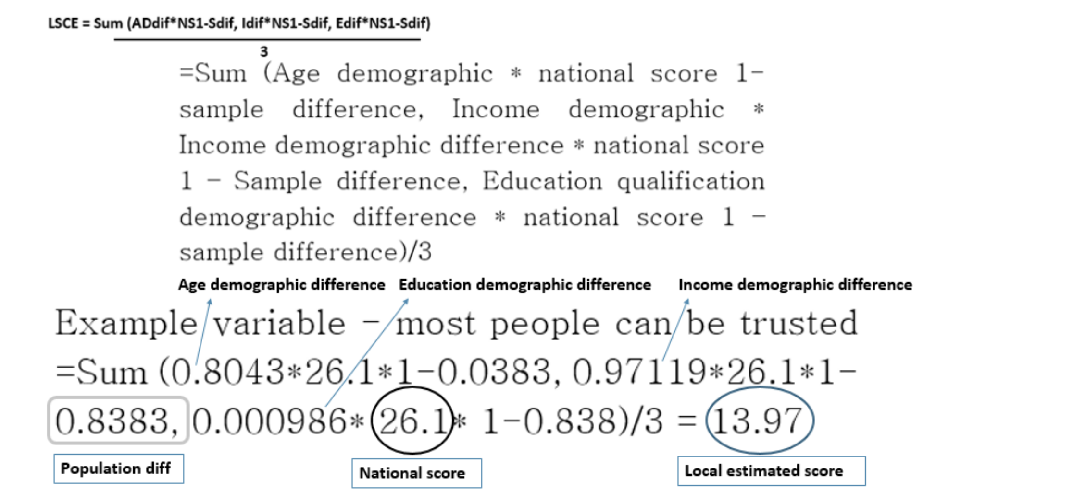

**The local study method:** The local study will be conducted through interviews. The quality of local services in a local area within a constituency level will be assessed through information gained through interviews. Interviews will be conducted with privileged actors who have had the most detailed experiences with local government and the 3rd sector over the last decade. This will provide the most detailed set of examples which may be able to identify more detailed causal pathways which current statistical based literature has not done, especially within a British context (Svendsen & Svendsen 2009). The reasons for the people selected can be found in more detail on p.5-p.6.

**Hypothesis:** H1: In a comparison of 2010 and 2001 this paper expects to observe a decline in both SC and Local government performance. This is based on (Putnam 1993) findings. H2: This paper expects to find a positive correlation between SC and local government performance, indicating some form of a relationship. This is based on (Putnam 1993) findings. H3: This paper would expect to find a complex relationship model when economic control variables are added, casting doubt over the initial relationship found between SC and government performance. This is based on (Whitely 2000) findings. H4: This paper expects to find a causal pathway where SC creates a civic culture which then creates better governance. This is based on (Almond & Verba: 1989 & Putnam 1993, 2000) analysis. H5: This paper expects to confirm the statement of New Labour’s local government policy was agency focused and enforced through a top –down centralised process. This is because of (Davies 2009 & Wilson 2011) analysis upon labour’s local government policy objectives tends to be the most convincing.

## Findings Chapter

## 

This study set out to find the exact trend of SC and its relationship to local government performance in the years 2000 to 2010. It specifically attempted to identify the exact nature of the claimed relationship. This dissertation particularly focuses on clarifying the issue of causal pathways, which does not always fully explain the relationship. It also set out to investigate if different types of SC affected local government performance more significantly than other types, for example bridging SC affecting local government performance more than trust SC. Finally, this dissertation set out to analyse the exact nature of local government. It analyses if it relies on an inclusive community sector, like New Labour reforms planned, or if it developed into an agency model, where services were contracted out to more private and exclusive bodies. Before reading this chapter the reader should be aware of the limitations. The main limitations to the national findings is the lack of statistical significance. Due to the lack of complete data this has resulted in a great difficulty to establish clear relationship between SC and local government performance. This is something that the reader should keep in mind when assessing the strength of the findings made here.

The national study & the local comparison study: Trends and correlation. H1: Firstly, the main finding of the national study consists of SC and government performance having both declined. SC has declined at roughly the same pace as local government performance. This is shown with figure 1. This finding is reinforced with a Pearson correlation test showing a significant correlation of (3.08*) again suggesting a clear trend. The local comparison study also reflects the correlation, trends and possible relationships reflected in the national study, strengthening the national study’s results:

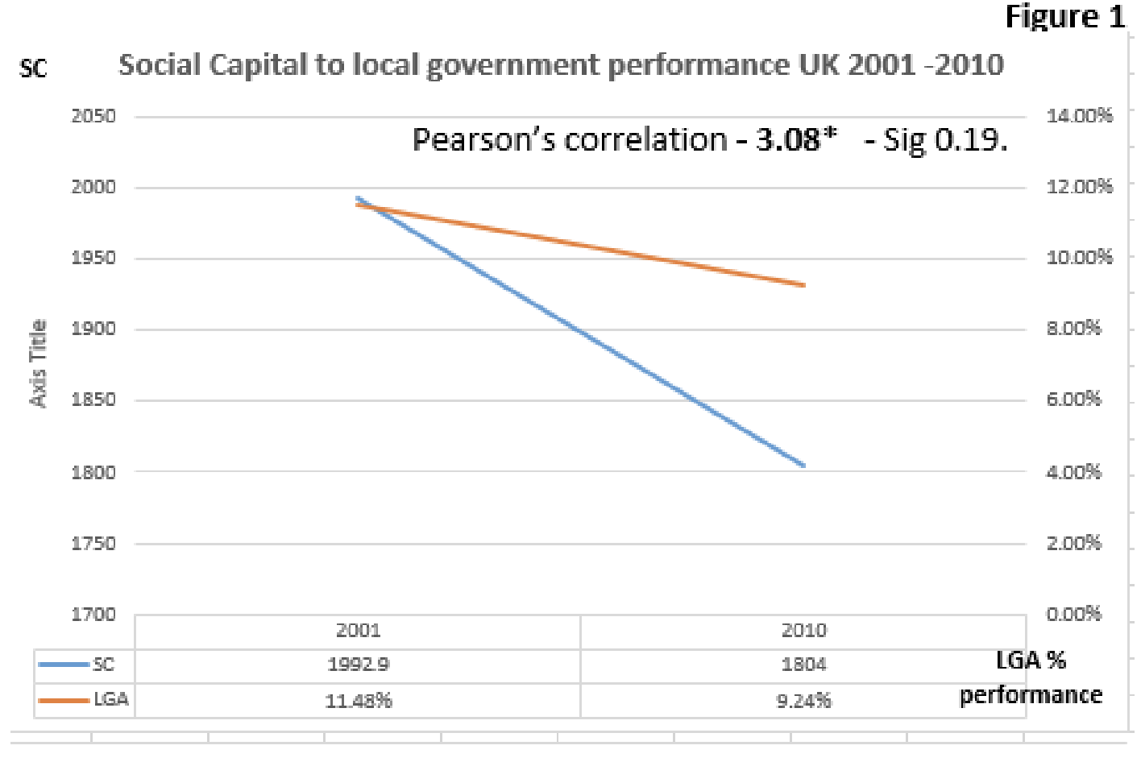

This builds on the current literature findings, and clarifies the debate around trends. Firstly, this study conflicts with Hall’s analysis which estimates SC in the UK has remained stable in recent decades (Hall in Putnam 2002). It also builds on Putnam’s measure of SC and confirms his trends (Putnam 2000). The study supports one side of the debate which suggests that SC has declined in recent times (Stoker 2004, Whiteley 2012). It also helps to clarify the debate around localism that has claimed citizen engagement in local groups has declined in recent times (Davies 2009). Furthermore, it helps to clarify the debate within British politics which suggests declining engagement, may be hurting the ability for better governance (Putnam 1993, Whiteley 2012, Stoker 2004). This is identified through declining citizen engagement, measured through SC, correlating with lower government performance. The analysis suggests lowering engagement can create lower performing governance; thus helping to add and clarify this confusing debate, especially within Britain.

Secondly, the local comparison study fits the trend of high SC with high local government performance, and low SC with lower performing governments compared to the national average. The local comparison study showed that councils which are experiencing a decline in estimated SC levels also experienced a decline in local government performance. Furthermore, it shows that areas that had an estimated increase in SC also had an increase in the performance of local government.

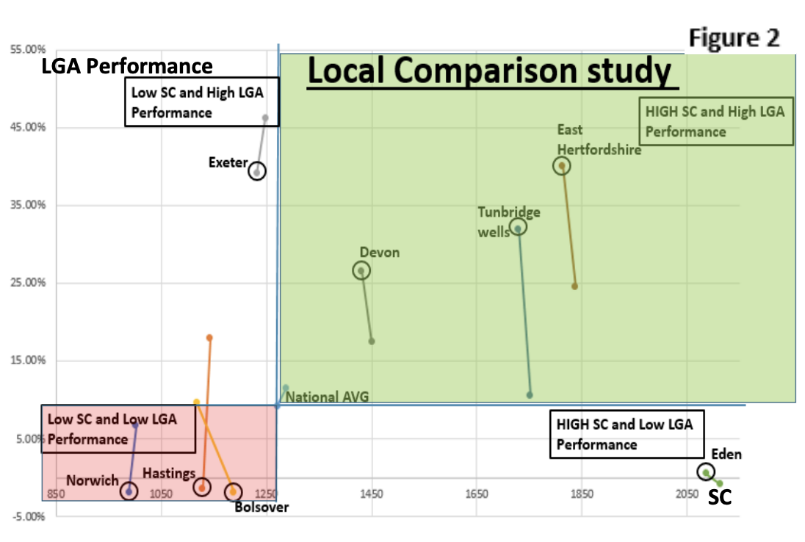

The local comparison study adds to the debate through clarifying local SC levels impact on government performance within Britain. It does this through a graph showing six of eight selected local councils. All councils which experienced a decline in SC experienced a decline in local government performance, again suggesting a trend. This is reflected in areas which had increasing SC also seeing a rise in local government performance. This again reinforces other evidence, through showing the same trends exists on a local level. It also supports and adds to other literature that has found similar localised findings (Whitely 2012 & Putnam 1993, 2000).

This particular finding contradicts other studies within the UK which suggests on a local level SC is not declining, and that SC levels always help local governance perform better (Lindsey 2011). This study instead suggests that the level of SC is important in determining the quality of local governance, if SC is declining it is possible it may negatively affect local governance, something which other studies do not suggest and largely have not investigated. Thus helping to clarify SC effect on local governance and address a gap in the literature.

Importantly, as these more localised findings reflect the national findings trends, suggesting trends may be generalizable across different areas within England. This conflicts with other research that suggests results found with SC and trends towards government performance cannot be generalised across different areas (Baron, Field, & Schuller: 2000), but supports (Putnam 1993).

There were two outliers. Exeter showed high levels of local government performance, but low SC. This highlights the key issue that there are more factors than just SC affecting governance trends. Exeter has a higher income and education levels than the national average. This can produce a higher council tax intake, resulting in more resources to manage services more effectively, creating a more content population. This reduces resistance to the implementation of services, making it far more cost effective. Also higher education levels, and a more skilled workforce, creates the ability to deliver the same services more efficiently. Secondly, as Eden is so affluent many services may not be thought of a needed, so the council is less responsive to the type of services being measured. Instead it spends money on other services like culture, sport and museums. This is reinforced with the measure of spending on these measures improving by 80%, whilst most other areas declined. Furthermore, tourism intake declined, suggesting a loss of revenue, after the recession, which may have hurt resources and in turn hurt council performance. Again reinforcing the national study and

model two findings that stress the importance of economic factors. Based on this we can accept H1. The calculation for all these finding can be found in more detail in the appendix, including mire detail to how the stratification method calculated the estimated SC levels.

|  |  |  |  |  |  |
| --- | --- | --- | --- | --- | --- |
| **Relationships** | | | **Regression Table 4 key models** | | |
| **Model number** | **Adjusted R Square** | **Dependent**  **Variable** | **Description** | **B coefficients** | **Sig / significance * 95% level** |
| **Govt performance to SC relationship model** | | |  |  |  |
| 1 | 7.9 | LGA2010 | Local government performance 2000-2010 |  |  |
|  |  |  | Social Captial’s yearly percentage change from 2000-2010 | -0.083 | -019* |
| **Govt performance to SC control variable model** | | |  |  |  |
| 2 | 16.6 | LGA2010 | Local government performance 2000-2010 | -1.621 | .837 |
|  |  |  | Social Captial’s yearly percentage change from 2000-2010 | -15.571 | .913 |
|  |  |  | Recorded unemployment in the economy according to the ONS | 20.860 | 0.87 |
|  |  |  | Recorded growth for the UK economy according to the ONS | 60.780 | .210 |
|  |  |  | Yearly change in real wage income according to the ONS | -.323 | .876 |
|  |  |  | Average age + education level | N/A | N/A |
| 3 | 48.8 | SCYPCH | Local government performance 2000-2010 | -0.17 | .534 |
|  |  |  | Social Captial’s yearly percentage change from 2000-2010 | 5.69 | 3.83 |
|  |  |  | Recorded unemployment in the economy according to the ONS | .201 | .030 |
|  |  |  | Recorded growth for the UK economy according to the ONS | -13.263 | 0.62 |
|  |  |  | Yearly change in real wage income according to the ONS | -2.078 | .342 |
|  |  |  | Average age + education level | N/A | N/A |
| **Different SC impact on LGA performance** | | | Local government performance 2000-2010 |  |  |
| 4 | 26.3 | LGA2010 | Bridging SC –associational membership | -0.24 | .994 |
|  |  |  | Institutions like trade unions and actions like volunteering frequency | -9.09 | .550 |
|  |  |  | Values such as expressing desire for community collective actions and beliefs, such as favouring collective action | .146 | .330 |
|  |  |  | Bonding SC – connection across family and close friends | .146 | .330 |
|  |  |  | Interpersonal trust (SAS) | N/A | N/A |

H3: Model one shows that without control variables SC is significant at the 95% level, and can explain 7.9% of the variation in declining local government performance. It suggests that a decline in SC has a decreasing effect on local government performance, suggesting a relationship.

Model two has control variables, such as economic factors, explaining 16.6% of local government variation can be taken into account. Also economic factors: particularly, growth, income, unemployment and sprawl are important. This is the same for the local comparison study. Importantly, sprawl is also affected by economic factors such as economic insecurity (Wroe 2014). This suggests other factors may influence local government performance alongside SC, providing more explanation of what creates the quality of governance within an area. This supports other relationship analysis such as (Brehm & Rahn, Campbell, Dalton 2004 Svendsen 2009 & Whitely 2000).

Secondly, model four highlights how different types of SC can affect government performance differently. Actions and institutions, values and beliefs with bridging SC affects local government more significantly than bonding and trust SC. Furthermore, it finds that SC affects different types of local government performance differently. For example SC appears to be more important in determining the quality of benefit services than in delivering financially sustainable budgets for the local council. This supports past evidence showing different SC has differing impacts on governance (Pattie 2004, Whiteley 2012, and Lowndes 2001). See appendix for more graphic details.

Finally, model three has found a possible endogenous problem of the discussed relationship SC has on local government performance but, local government appears to also determine some of the variation within SC levels over the investigated time period. This particular model shows that SC trends are dependent on partly local government performance and also economic factors; particularly income, and unemployment. This would suggest that the relationship between SC and local government performance could be endogenous and reliant on a multitude of different factors which complicates the relationship. This analysis can explain an expected 48.8% of the variation of SC. The endogenous problem reflects past research and criticisms of SC research which consists of (Baron, Field, & Schuller: 2000 & Sabetti in Biox 2009). Based on this we can neither accept nor reject H2.

This last finding created much confusion; this study has decided to further investigate possible relationships through interview analysis of one focused case study, Hastings. This should also help identify causal pathways behind this complex and unclear statistical relationship.

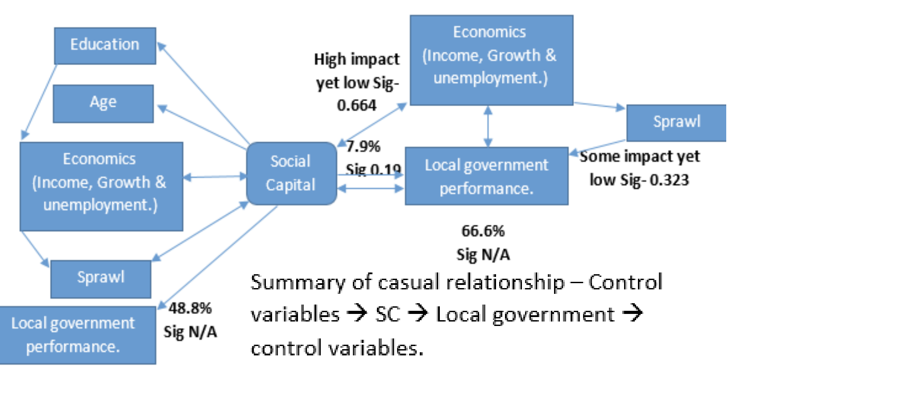

**Local study trends**

Overall there is substantial evidence to show that SC in Hastings has declined. This is reflected through institutional SC declining, declining numbers of community groups (bridging SC) and a noticeable decline in people engaging with community groups.

In particular councillors commented on community infrastructure, in the form of community centres, forums and resident and traders associations declining.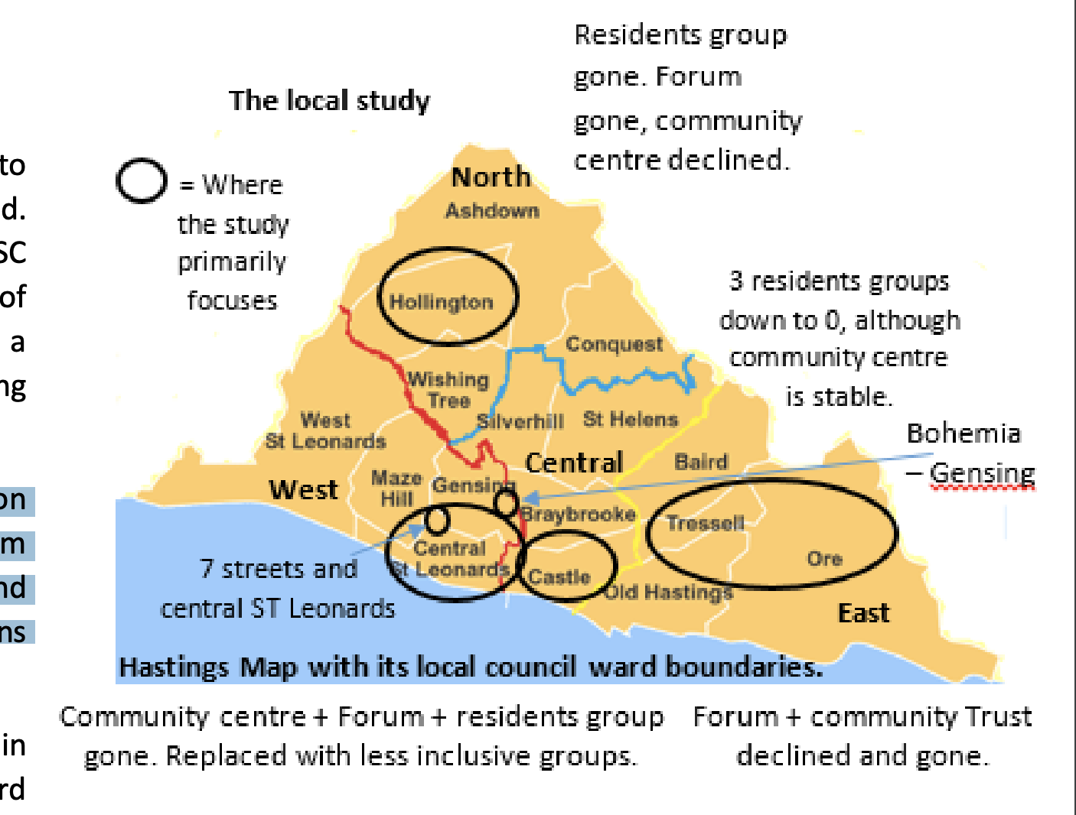

Cllr Peter Chowney described how in Tressell ward, an area covering a third of the east side of town, there once was three resident groups, now there are none. Cllr Trevor Webb stated this was similar in the West and central areas of the town. He said both Forums and residents groups have slowly disappeared over the last decade, and more recently the community centre in the West part of town, St Leonards, closed down. Importantly, this shows that SC is not just in decline in the whole of Hastings, but in many sub local areas, meaning council ward areas, suggesting the trends can be generalised down to even more local levels than just Hastings itself. Supporting the idea again that trends can be generalised (Putnam 1993, Halpern 2000 & Pattie 2004).

To summarise all councillors mostly stated Cllr Peter Chowney’s comments which stated, “People just do not participate in groups anymore. Residents groups that were there are mostly gone and people lead more isolated and atomised lives, making collective action less common although it still exists in some areas.” This reinforces past arguments made by (Davies 2009, Putnam 1993, 2000, 2002 & Halpern 2005).

A lack of trust is apparent within Hastings. Trust in official residents’ and traders’ associations, and especially a lack of trust in the local council, reinforcing the claim that SC has overall declined.

Community worker Chris Connelly, commented how he often observed that many people would not join official residents and community groups because they did not trust organisations that involved very formal meetings and membership status. He went onto discuss how a lot of community groups fail to attract many people, and often the same people, because a lot of these groups invited the council, police and other authority bodies to meetings, which often put people off. This was largely because many people no longer trusted these authorities and people associated with them. This was reinforced through Cllr Andrew Cartwright also suggesting that many people did not engage with community based council meetings and the neighbourhood watch panel group because many people no longer trusted these groups and did not engage with them as a result.

This often hurt community group’s ability to form networks that can help facilitate reciprocity and overcome collective action problems, resulting in a lack of SC being formed and reinforcing the trends already found (Putnam 1993, Whiteley 2012 & Hall in Putnam 2002).

**The nature of local government.**

Councillor’s expressed much concern to how they felt that community involvement with the council was being weakened through services being consistently contracted out. Hastings’ council leader, Jeremy Birch discussed how recent reform, especially the most recent cuts reforms made in 2011, have increasingly forced councils to rely on outside agencies to deliver services, especially in education and refuse collection services. Also Cllr Chowney discussed how the regeneration projects, once mainly led by community groups and the third sector, is increasingly being contracted out to private agencies. Furthermore, the services which community sectors have involvement in have also experienced a reduced ability to contribute engaging in the delivering of services. Steve Mannering, who leads Hastings voluntary action, discussed how less resources, but more pressure on the third sector due to the economic and cuts situation, resulted in the sector’s reduced ability engage with the council. Importantly, this means that community groups may be able to change less things locally than in previous times, making joining these groups less appealing. This may result in a further decline of SC.

Crucially, this impacts upon the debate surrounding New Labour’s policies on local government reform. It was designed to put community groups at the heart of service provision, but as seen with Hastings this has not happened (Davies 2009 & Wilson 2011). This may have been because during the economic boom Whitehall may have changed policy as it favoured the efficiency of private organisations. During the downturn it may have been cheaper to keep it in private agency hands, as consultation costs money. Therefore this supports (Davies 2009 & Wilson 2011) view on local government being an agency model and not (Stoker 2004) view who sees it a community network model. Importantly, this also creates a debate that either New Labour’s reforms changes through its time in office or started as an attempted to extend the privatisation Thatcherism started.

**Causal pathways.**

H4: The interview highlighted causal pathway one. This occurs through consultation, information gathering and political representation functions local councils usually engage in. Firstly, one example was the case of waste disposal and cleanliness services. Cllr Cartwright and community worker Connelly both agreed that delivering waste disposal services relied on community groups acting and providing information to the council. This can be seen with different areas, where one area in Central St Leonards had much lower SC and waste collection services than another area, Bohemia in Gensing, which had higher SC and better waste collection services. On further questioning it was revealed that this was the case because of community groups. The Bohemia residents and traders association noticed the waste problem and through regular meetings created the idea of Seagull proof bin bags, which stopped seagulls spreading waste around the local area. In the other area where no community groups are present a new set of delivered bins, in an attempt to improve the litter problem, resulted in failure because the bins were too small for people to put there bin bags through. As the council did not have information, unlike in the Bohemia case, the council resulted in implementing something at large cost that did not address the particular needs of the local people. This shows how community groups’ actions and vital information can result in better quality and delivered services, and how a lack of these groups can result in inefficient services, and poorer governance, which may cause more distrust in councils ability to perform, creating resistance and again lower government performance levels. Showing how these groups can again make it easier for local government to perform at a higher level, supporting literature which argues this (Putnam 1993, Davies 2009, Halpern 2005 & Whiteley 2012).

**Pathway 2** is exemplified through several accounts, particularly Collenelly’s interview involving what was the 7 streets project. He stated “that people in these groups bring up their own initiatives, which usually were designed to address the key social issues.” As this group was set up to tackle local social problems and low SC this created many initiatives aimed at tackling these social issues. Collenelly particularly talked about the “street cleaning and housing projects, aimed at improving local living conditions.” Also another example can be found with Mannering’s account which showed that environmental groups, trained by the third sector, cleaned rivers and help clean local areas. Importantly, this helped the council deliver housing and cleaning services.

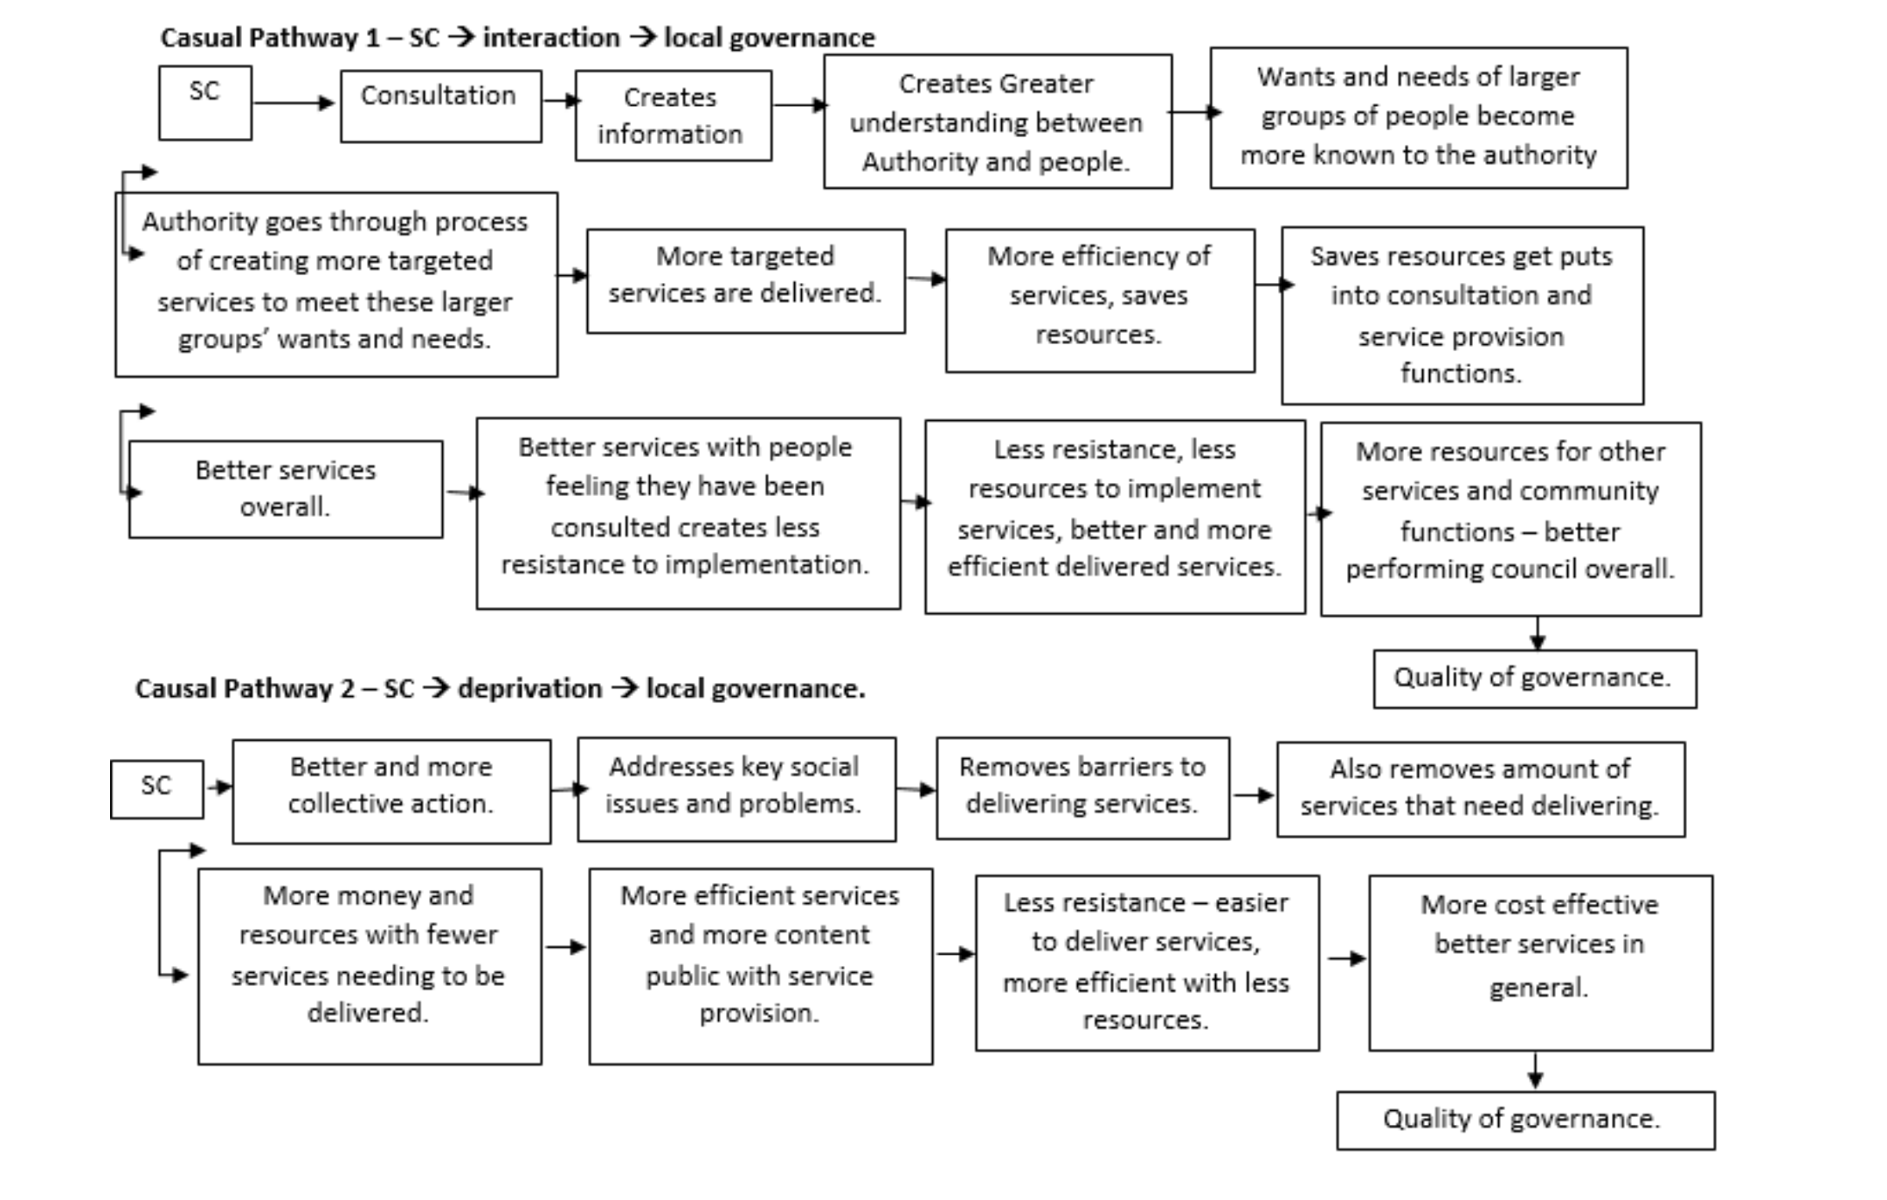Cllr Cartwright also explained that this was the same process for groups in Gensing which helped with social issues like speeding through taking the registration of cars caught speeding, helping to deliver policing services. This was also the case with groups keeping alleyways clean in the local area, helping the council to deliver cleaning services.

Mannering discussed several community projects where volunteer groups would help with educational support, especially in early year’s education. This included volunteer groups helping children to read and giving educational support to those in deprived communities. This helps the council not just deliver education services, but over the long term have a population which is more educated, needing less services, and more able to pay higher taxes. This produces a positive long term effect which makes it easier for councils to deliver services. This also support evidence that SC can help educational development, which overtime improves governance (Coleman 1988).

All this shows evidence that SC can create more effective collective action to address social problems. This in turn removes barriers councils’ face in delivering services, and reduces the amount of social services which need delivering. This means that more resources can be used for fewer services, making more efficient and highly performing governance. This makes people more content with government decisions, producing less resistance, again making it more cost effective to implement services, improving levels of governance.

Finally, interview analysis highlighted an endogenous problem within the relationship. It showed that SC success, in particular community groups, is partly dependent on local government performance. Yet, local governments’ ability to deliver services is partly dependant on the strength of SC within the local area a service is being delivered. Cllr Birch summarised a possible endogenous relationship through saying “the council relies on these groups to perform and deliver services, but these groups sometimes rely on us to help them to succeed in their goals.” He then went onto give an example how the council compulsory purchased the dilapidated pier, which supported a community group’s campaign to restore the pier. Shortly after this a rise in community engagement around the pier area occurred. Again this issue was most evident when every councillor interviewed said they attended community group meetings and helped certain groups function. All the third sector workers interviewed said how their group delivered certain services on behalf of the council, for example HVA delivering benefit services and information advice in benefits. Another group also helped the council deliver children services in an area with little children services. This presents an important problem as it makes observation of this type of relationship incredibly difficult. Moreover, it has a lot of implications on existing literature, most notably it contradicts work which suggests that a direct relationship may be present (Putnam 1993), casting doubt on these key works claims accuracy, suggesting we must reject H4.

These findings mainly add to the debate by building on Putnam’s measure of SC which confirms Putnam’s trend. It further adds through clarifying the current relationship that surrounds SC and local government, it suggests that a relationship of SC and certain economic factors greatly impacts local government performance and the relationship at time can be endogenous. It also clarifies current trends of SC, which is a declining one that affects declining local government performance. Through doing this this paper has addressed a key gap in the literature, a lack of local government focus and SC within Britain meaning more generalisations may be possible.

It provides clarity around the nature of local government where it is mainly about service provision and contracting pout to less inclusive outside agencies, not about community network governance as some have argued. It supports (Davies 2009, Wilson 2011) which states it is a complex agency model where services are contracted out to many different bodies, and disagrees with analysis which states it is a community network led service system (Stoker 2004 and Lindsey 2011). This suggests we must accept H5.

## Conclusion Chapter

In summary the findings from this paper demonstrate declining trends in both SC and local government performance. The causal pathway identified shows that community groups enhance local government performance through providing vital information which helps a local authority gain a greater understanding of its citizens’ service needs. This then leads to more targeted and efficient service provision, helping to increase the quality of governance. Also SC tends to reduce social barriers, such as reducing deprivation, which can impede higher governance levels through draining resources and making service provision more complex. The relationship is slightly endogenous, which this dissertation would conclude through saying the SC that currently exists can be facilitated through council help, but cannot be created by local governments. The dissertation finds that different types of SC helps the quality of governance more than other forms of SC. This dissertation also finds that council services are mainly about service provision and not community involvement as other theories have suggested.

This dissertation has mainly added greater clarification through providing new data and trends, through graphs. It has added to Putnam’s measure of SC, through using SC as one figure. It has clarified the debate around whether different types of SC affect local governance differently. It has added through providing a new focus on local government within Britain, suggesting generalisations can be made of Putnam’s works. Also as stated above it has added through providing a different perspective on the causal pathways.

**Implications** of these results are, firstly it identifies that a declining trend of SC may be existent within localities and sub localities, Like Hastings, Central Hastings and as small a level as the seven streets within central St Leonards. This conflicts with previous local SC studies within Britain (Olivia, Stoker 2004) and confirms (Davies 2009). Importantly, this suggests that the results may be generalizable to several local areas across Britain. Supporting (Jacobs 1961, Putnam 1993, 2000 and Harvey 2005) argument, these results are generalizable.

Further, the local study shows how a causal relationship may exist within a British local government context. This supports previous evidence stating a relationship exists (Putnam 1993, Halpern 2005 & Stoker 2004), and contradicts other claims which suggests the relationship is too vague to understand (Baron, Field, & Schuller: 2000 and Frane 2007 and Boix 2009). It also shows how economic factors can be important in the relationship, suggesting a more complex relationship (Whiteley 2012, Putnam 2000, Menaham 2011, Saegert 2001, Coleman 1988, Tomsic 2007 & Lewandowskim 2007.)

Secondly, the local study shows how trust and reciprocity is important in the causal process through creating SC, which creates better governance. This strengthens SC analysis (Putnam, Coleman, Field 2003 and Hanifan 1916).

Finally, causal pathway findings contradict other findings and suggest it purely informs knowledge to produce more efficient service processes instead. This suggests that current explanations, especially inferring the civic culture creates a behaviour that creates better governance, may be wrong (Putnam, Almond & Verba 1963 , Warren 2001, Hooghe 2003, De Tocqueville 2003, Svendsen 2009 & Halpern 2005).

The wider impact upon SC research is primarily on measurement and methodology of possible future research. This dissertation stresses the importance of future SC research keeping the single measure of the SC concept. It would also stress future use of the stratification method to limit the negative impact of a lack of local statistical data in most SC research. This dissertation also impacts SC research in suggesting that more of a focus on local case studies, especially though the use of interview analysis, is needed to establish clearer causal pathways. The dissertation suggests that if this method is used more generalisations of trends and relationships, on a more localised level, may be possible. This shows Putnam’s research may be generalizable, reinforcing past literature (Putnam 2000). It also suggests that criticism of this type of research in its lack of established causal pathways, ability to overcome the endogenous problem and current issues with the lack of generalizability, may all be credible criticisms. Future research may need to take more of a local case focus, with interview analysis to help overcome these problems and establish the exact nature of generalisations, trends and relationships which can be made. Also it may help establish the level of its endogeneity and more concrete set of causal pathways.

This dissertation also deeply impacts upon British political literature, supporting literature which argues political and civic engagement has declined in recent times (Putnam 2000). This would also have an impact on wider political literature, especially trust literature, which suggests there may be a crisis in democratic nations, most exemplified through decreasing engagement in the collective political process (Stoker 2004.) This dissertation suggests that collective actions nationally have declined, representing a difficulty in mobilisation of collective forces to address large political problems. This may result in a less effective effort to tackle to biggest political issues of the day, especially as people are more atomised and individually motivated (Warren 2001). This may lead to institutions being viewed as less able to address people’s issues, resulting in declined confidence and trust in institutions, which may present a threat towards democracy (Warren 2001). This implication suggests SC and trust research is highly relevant for political analysis.

It also has a slight impact on the British localism and local government debate, through supporting literature which suggests that localism and local government have been weakened in recent times (Davies 2009). It would suggest that local government has been increasingly top down, directed by national government. It follows an agent model which forces to contract more services out to private agencies, weakening local control and involvement in local service provision.

Finally, implications of this paper involve a real political world aspect. It directly addresses the debate surrounding local government, how to most effectively implement efficiency savings set by the national government. This dissertation argues it would appear that saving money through cutting the resources supplied to local government may not be the best way to implement the efficiency savings. This is because it restricts the council’s ability to interact with groups, lowering the amount of information they can acquire before implementing local services. It also places more pressure on community and voluntary sectors, which are required to deliver more services with lower budgets and support from the council (Mannering 2015). This means that the best way to create more efficient and value-for-money local government would be to protect funding for local government in terms of support for 3rd sector funding, whilst also finding more cost-efficient ways to deliver services.

This dissertation would recommend further research to use this measure of SC to analyse if SC has any effects on social attitudes towards government, which would mean this dissertation’s methodology entering the area of trust research. This could be done through using the SAS to see if issues like governmental trust is at all affected by SC. This would provide greater understanding to an argument made in this dissertation that lowering SC and collective action levels, may be resulting in poorer performing governance, decreasing people’s faith in democratic institutions, resulting in a weakening of democracy Importantly, one limitation is in control variables, such as economic factors, making identified relationships a lot more complex. Further research could build on past studies trying to identify the relationship of economic factors and SC relationship to governance quality, which affects support for the democratic system (Terrance 2004) to try and identify a more accurate relationship model, which can explain more of the variation in government performance levels.

Bibliography

#### 

Bibliography Primary Sources: (Data sets & Interviews).

* SAS
* BHPS
* HOCS
* BES
* ONS
* Neighbourhood statistics
* ONS census
* Cllr Birch
* Cllr Cartwright
* Cllr Chowney
* Cllr Webb
* Steve Mannering
* Chris Connelley

**Secondary Sources:**

* Adams, Andrew. "Social Capital, Network Governance and the Strategic Delivery of Grassroots Sports in England." International Review for the Sociology of Sport 49, no. 5 (2014): 550-574.
* Almond, Gabriel A. and Sidney Verba. The Civic Culture (Princeton: Princeton university press, 1963.)

———. The Civic Culture Revisited (London: Sage, 1989).

* Andrews, Rhys. "Exploring the Impact of Community and Organizational Social Capital on Government Performance: Evidence from England." Political Research Quarterly 64, no. 4 (2011): 938-949.
* Bakker, J., B. Denters, M. Oude Vrielink, and P. KLOK. "Citizens' Initiatives: How Local Governments Fill their Facilitative Role." Local Government Studies 38, no. 4 (2012): 395-414.
* Baron, Stephen, John Field, and Tom Schuller, eds. Social Capital: Critical Perspectives (Oxford: Oxford university press, 2000).
* Bennett, W. Lance. "The UnCivic Culture: Communication, Identity, and the Rise of Lifestyle Politics." Political Science and Politics 31, no. 04 (1998): 740-761.
* Blair, Tony. Leading the Way: A New Vision for Local Government. London: Institute for public policy research, 1998.

———. . Modern Local Government: In Touch with the People. London: H.M.S.O, 1988

* Boix, Carles and Susan C. Stokes, eds. The Handbook of Comparative Politics. Democracy and the Civic Culture, edited by Sabetti, Filippo (Oxford university press: Oxford, 2009).
* Bourdieu, Pierre. "The Forms of Capital." marxists.org, accessed 23/10/2014, 2014, <http://www.marxists.org/reference/subject/philosophy/works/fr/bourdieu-formscapital.htm.>
* Bowman, Sam. "Local Government Cuts needn’t be the End of the World." Adam Smith Institute, accessed 15/01/2015, 2015, <http://www.adamsmith.org/blog/politics-government/localgovernment-cuts-neednt-be-the-end-of-the-world/>.
* Brehm, John and Wendy Rahn. "Individual-Level Evidence for the Causes and Consequences of Social Capital." American Journal of Political Science 41, no. 03 (1997): 999-1023.
* Campbell, William Ross. "the Sources of Institutional Trust in East and West Germany: Civic Culture Or Economic Performance?." German Politics 12, no. 03 (2005): 401-418.
* Casey, Terrance. "Social Capital and Regional Economies in Britain." Political Studies 52, no. 01 (2004): 96-117.
* Clarke, Harold D., Allan Kornberg, Chris McIntyre, Petra Bauer-Kaase, and Max Kaase. "The Effect of Economic Priorities on the Measurement of Value Change: New Experimental Evidence ." American Political Science Review 93, (1999): 637-647.
* Clarke, D. Harold, David Sanders, C. Stewart Marianne, and Paul Whiteley. Performance Politics and the British Voter (Cambridge: Cambridge university press, 2009).
* Coleman, James S. "Social Capital in the Creation of Human Capital." American Journal of Sociology 94, (1988): 95-120.
* Dalton, Russell J. Democratic Challenges, Democratic Choices: The Erosion of Political Support in Advanced Industrial Democracies (Oxford: Oxford University Press, 2004).
* Dollery, B., B. Grant, and Lin Crase. "Love Thy Neighbour: A Social Capital Approach to Local Government Partnerships." Australian Journal of Public Administration 70, no. 1 (2011): 156-166.
* Edwards, Rosalind, Jane Franklin, and Janet Holland, eds. Assessing Social Capital: Concept, Policy and Practice. Newcastle: Cambridge Scholars published, 2007. Field, John. Social Capital (London: Routledge, 2003).
* Flinders, Matthew, Andrew Gamble, Colin Hay, and Michael Kenny, eds. The Oxford Handbook of British Politics. Localism, edited by Davies, Jonathan (Oxford: Oxford university press, 2009).

———. The Oxford Handbook of British Politics. Localism, edited by Davies, Jonathan (Oxford: Oxford university press, 2009).

———. The Oxford Handbook of British Politics. Participation and Social Capital, edited by Whiteley, Paul (Oxford: Oxford university press, 2009).

* Frane, Adam. "The Distribution of Social Capital and the Quality of Data from Cross National Surveys ." In Social Capital and Governance: Old and New Members of the EU in Comparison , edited by Adams, Frane (Berlin: Transaction publishers, 2007).
* Franklin, Jane, Janet Holland, and Rosalind Edwards. "Whither Social Capital?" In Assessing Social Capital: Concept, Policy and Practise, edited by Franklin, Jane, Janet Holland and Rosalind Edwards. Newcastle: Cambridge Scholar, 2007.
* Golding, Nick. "Local Government Chronicle.", accessed 16/11/2014, , <http://www.lgcplus.com/.>
* Goodwin, Guy. "ONS: Social Capital." ONS, accessed 23/11, 2014, <http://www.ons.gov.uk/ons/guide-method/user-guidance/social-capital-guide/index.html>
* Halperin, Sandra and Oliver Heath. Political Research: Methods and Practise Skills (Oxford: Oxford university press, 2012).
* Halpern, David. Social Capital (Cambridge: Polity Press, 2005).
* Hanifan, L. J. "The Rural School Community Centre." American Academy of Political and Social Science 67, (1916): 130-138.
* Hanretty, Chris and Nick Vivyan. "Constituency Opinion and Representation in Britain.”, accessed 20/11, 2014, <http://constituencyopinion.org.uk/wpcontent/uploads/2014/10/booklet_with_cover.pdf>.
* Hanretty, Chris. "How Eurosceptic is Rochester and Strood." accessed 11/24, 2014, <http://blogs.lse.ac.uk/politicsandpolicy/how-eurosceptic-is-rochester-and-strood/.>
* Heffernan, Richard, Philip Cowley, and Colin Hay. Development in British Polirtics 9 (Basingstoke: Palgrave MacMillian, 2011).
* Hetherington, Marc J. "The Effect of Political Trust on the Presidential Vote." American Political Science Review 93, no. 02 (1999): 311-326.
* ———. "The Political Relevance of Political Trust." American Political Science Review 92, no. 02 (1998): 791-808.
* Hetherington, Marc J. and Thomas J. Rudolph. "Priming, Performance, and the Dynamics of Political Trust." Journal of Politics 70, (2008): 498-512.
* Holman, Nancy. "What can Social Capital Tell Us about Planning Under Localism?" Local Government Studies 39, no. 1 (2013): 71-88.
* Hooghe, Marc and Dietlind Stolle, eds. Generating Social Capital: Civil Society and Institutions in Comparative Perspective (Basingstoke: Palgrave Macmillan, 2003).
* Inglehart , Ronald. Modernization and Postmodernization: Cultural, Economic and Political Change in 43 Socities (Princeton, New Jersey: Princeton University Press, 1997).
* Inglehart , Ronald and Paul R. Abramson. "Measuring Postmaterialism." American Political Science Review 93, (1999): 665-687. Jacobs, Jane. The Death and Life of Great American Cities (New York: Random house, 1961).
* Jacotine, Clive and Nick Wates. Main Report: Neighbourhood Renewal Team,
* Hastings Borough Council. Hastings: Hastings Borough Council, 2004.
* Kampen, Jarl K. "On the (in)Consistency of Citizen and Municipal Level Indicators of Social Capital and Local Government Performance." Social Indicators Research 97, no. 02 (2010): 213-228.
* Kelly, Ruth. Strong and Prosperous Communities: The Local Government White Paper (London: HMSO, 2006).
* Kramnic, Issac. Alexis De Tocqueville: Democracy & Two Essays on America. Translated by Gerald E. Bevan (London: Penguin, 2003).
* Lane, Robert E. "The politics of consensus in the age of affluence.” American Political Science Review 59, no. 04 (1965): 874-895.
* Leese, Richard. July 2014 Final Report: People-Powered Public Services. Westminster: Local Government Innovation Taskforce, 2014.
* Lewandowskim, Joseph D. "Capitalism Sociability: Rethinking the Theory of Social Capital ." In Assessing Social Capital: Concept, Policy and Practise , edited by Franklin, Jane, Janet Holland and Rosalind Edwards (Newcastle: Cambridge Scholars, 2007).
* Lindsey, Elizabeth O. D. "Social Capital and New Localism: A Comparative Study of Two Parish Councils (Kent university, Rutherford college, 2011).
* Lowndes, V. and D. Wilson. "Social Capital and Local Governance: Exploring the Institutional Design Variable." Political Studies 49, no. 4 (2001): 629-647.
* Lucas, Caroline. Early Day Motion 579: Local Government Funding . London: House of commons UK, 2014. Lupton, Ruth, Alex Fenton, and Amanda Fitzgerald. Labour’s Record on Neighbourhood Renewal in England: Policy, Spending and Outcomes 1997-2010. London: LSE, July 2014.
* Menaham, G., G. Doron, and D. I. Haim. "Bonding and Bridging Associational Social Capital and the Financial Performance of Local Authorities in Israel." Public Management Review 13, no. 5 (2011): 659-681.
* Mugan, Anthony and Dean Lacy. "Economic Performance, Job Insecurity and Electoral Choice’, British Journal of Political Science." British Journal of Political Science 32, (2002): 513- 533.
* Naysmith, Stephen. "Scottish Government Accused of Ignoring Social Capital." The Herald,June 2, 2009. Newman, Jeremy. "Audit Comission Performance: Indicators and Data Sets." Audit Commission group, accessed 06/01, 2014, <http://archive.auditcommission.gov.uk/auditcommission/Pages/default.aspx.html.>
* Park, David K., Andrew Gelman, and Joseph Bafumi. "Bayesian Multilevel Estimation with Poststratification: State-Level Estimates from National Polls." Political Analysis 12, (2004): 375- 385.
* Pattie, Charles, Patrick Seyd, and Paul Whiteley. Citizenship in Britain: Vales, Particiaption and Democracy (Cambridge: Cambridge university press, 2004). Pickels, Eric. "Department for Communities and Local Government.", accessed 13/11/14, <https://www.gov.uk/government/organisations/department-for-communities-and-localgovernment.>
* Pollock, Philip H. The Essentials of Poltical Analysis (Washington DC: CQ Press, 2012).
* ———. An Spss Companion to Political Analysis (Washington DC: CQ Press, 2012). Putnam, Robert D. Better Together: Restoring the American Community (New York: Simon & Schuster, 2004).
* ———. Bowling Alone: The Collapse and Revival of American Community (New York: Simon & Schuster paperbacks, 2000).
* ———. Democracies in Flux: The Evolution of Social Capital in Contemporary Society (Oxford: Oxford university press, 2002).
* ———. Making Democracy Work: Civic Traditons in Italy (Princeton: Princeton university press, 199).
* Roskruge, Matthew, Arthur Grimes, Philip McCann, and Jacques Poot. "Homeownership, Social Capital and Satisfaction with Local Government." Urban Studies 12, no. 9 (2013): 2517-2534.
* Ruston, Dave and Lola Akinrodoye. ONS: Social Capital Question Bank. London: ONS, 2002.
* Saegert, Susan, J. Phillip Thompson, and Mark R. Warren, eds. Social Capital and Poor Communties (New York: Russel Sage Foundation, 2001).
* Scheve, Kenneth and Matthew J. Slaughter. "Economic Insecurity and the Globalization of Production." American Journal of Political Science 48, no. 04 (2004): 662-674.
* Simon, Parker. "Budget 2014: A Good Day for the Economy, a Bad Day for Public Services." The Guardian, 19 March 2014, 2014. Smith, Mark K. "Social Capital." 2014, <http://infed.org/mobi/social-capital>.
* Stoker, Gerry. Transforming Local Democracy: From Thatcherism to New Labour (Basingstoke: Palgrave Macmilan, 2004).
* ———. Why Politics Matters: Making Democracy Work (Basingstoke: Palgrave MacMillan, 2006). Svendsen, Gert T. and G. L. Haase Svendsen, eds. Handbook of Social Capital : The Troika of Sociology, Political Science, and Economics (Cheltenham: Edward Elgar, 2009).
* Tomsic, Matevz and Urban Vehovar. "Quality if Governance in the European Union: Old and New Members in a Comparative Perspective (Berlin: Transaction publishers, 2007).
* ———. "Social Capital and Governance: Old and New Members of EU in Comparison." In Social Capital and Governance: Old and New Members of the EU in Comparison , edited by Frane, Adam (London: Transaction publishers, 2007) Sub-National and Local Government Lecture. Directed by Travers, Tony. London: LSE, 2014.
* Uslaner, Eric. "Trust, Civic Engagement, and the Internet." Political Communication 21, (2004): 223-242. Wallis, J. and B. Dollery. "Social Capital and Local Government Capacity." Australian Journal of Public Administration 61, no. 3 (2002): 76-85.
* Warren E., Mark. Democracy and Association (New Jersey: Princeton university press, 2001). Whiteley, Paul. Political Participation in Britian: The Decline and Renewal of Civic Culture. (Basingstoke: Palgrave MacMillan, 2012).
* Whitely, Paul F. "Economic Growth and Social Capital." Political Studies 48, (2000): 443-467.
* Widdecombe, Ann. The Conduct of Local Authority Business: The Government Response to the Report of the Widdicombe Committee of Inquiry (London: H.M.S.O, 1988).
* Wilson, David and Chris Game. Local Government in the United Kingdom. 5th ed (Basingstoke: Palgrave MacMillan, 2011).
* Wroe, Andrew. "Political Trust and Job Insecurity in 18 European Polities." Journal of Trust Research 4, no. 02 (2014): 90-112.

Appendix

This is the population of one local authority for a given year, allows a comparison of the population to the surveys population.



These are the outputs generated to represent a difference in a local authority’s population and key demographics compared to a particular survey’s population and demographics – these are the numbers used to produce the estimate for the local SC level. For example if the variable used to calculate social capital came from the HOCS you would use these numbers in the formula to generate a local estimate. If the variable came from the BHPS survey then you would use these numbers to calculate the local average for that particular variable. You use each set of numbers dependent on the year being measured.

This is the population’s key demographics for a given year, allowing for a comparison of the local authorise demographics to the surveys demographics.

### This is the population’s key demographics for a given year, allowing for a comparison of the local authorise demographics to the surveys demographics.

#### Formula breakdown



These above 4 tables **_HOCS_, _BHPS_, _BES_, _BSAS_** are indicative of the outputs generated to represent a difference in a local authority’s population and key demographics compared to a particular survey’s population and demographics – these are the numbers used to produce the estimate for the local SC level. For example if the variable used to calculate social capital came from the **_HOCS_** you would use these numbers in the formula to generate a local estimate. If the variable came from the **_BHPS_** survey then you would use these numbers to calculate the local average for that particular variable. You use each set of numbers dependent on the year being measured.

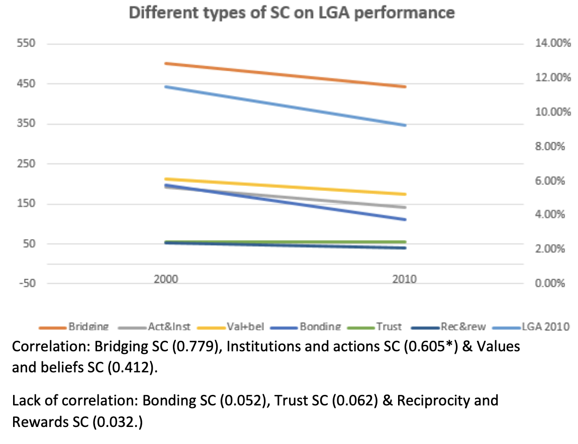

## 

## LGA Performance Table

This LGA performance graph shows that despite one type of SC may correlate with local government performance across a time period it does not necessarily means causation. For example the decline in binding SC highly correlates, but has little statistical significance, shown in model 4.

This is again reflected with the correlational relationships, where some types of SC were more correlated with declining local government performance than others were.

We have focused upon local government, and Hastings local government in this part of the book, we now go onto focus upon social capital trends in a more local focus, which will focus specifically upon the council borough, Hastings.